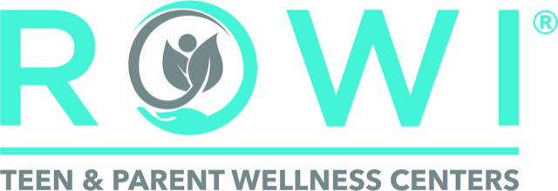 | Records Request Quick Reference Guide

Records Request — Quick Reference
For parents and families with questions about requesting records

The Short Version
To request records from ROWI, you need three things:

- The form: Download the Authorization for Release of Confidential Information from rowiteens.com.
- The right signature: If your teen is 12 or older, they must sign — not you. This is California law.
- The fax number: 805-506-3084. Fax to the Records Department. Do not email. Do not call Admissions.

Processing takes up to 15 calendar days (California Health & Safety Code § 123110).

Why Can't I Access My Teen's Mental Health Records?
California law gives teenagers age 12 and older privacy rights over their mental health records. This means a provider may limit what a parent can access — not because ROWI is withholding information, but because state law requires it. The same law is why your teen must sign their own release form.
This applies even if you have sole legal custody. A court order specifically directing the release of records is the appropriate channel if you believe legal grounds exist.

Why Is Admissions Telling Me They Can't Help?
The Admissions team handles new client intake and enrollment. They do not have access to clinical records systems and cannot process, track, or release records requests. Every call or message to Admissions about records adds delay — please fax the completed form directly to the Records Department.

Checklist Before You Fax

☐ | I downloaded the current ROWI records release form from rowiteens.com
☐ | Patient name and date of birth are filled in
☐ | Recipient name, address, and fax number are filled in
☐ | I have checked the boxes for what records I need
☐ | I selected a reason for release
☐ | If my teen is 12 or older, my teen has signed the form
☐ | If my teen is under 12, I have signed as parent/guardian
☐ | I am faxing to 805-506-3084 (Records Department — not Admissions)

Records Department Fax  805-506-3084 | Processing Time  Up to 15 calendar days  per CA Health & Safety Code § 123110

For full details, see the Parent Facts page at rowiteens.com | ROWI Teen & Parent Wellness Centers | Records Fax: 805-506-3084

